Lokesh Bagmare

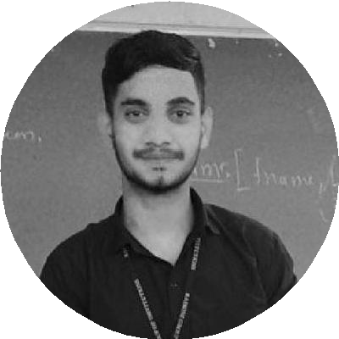

### AI Student , Quick learner and Fireﬁghter

Hi, I am Lokesh , eager to learn, independent and Technophile. Soon-to-be Artiﬁcial Intelligence Graduate. Eager to continue exploring the inspiring, innovate ﬁeld of AI & ML.

[bagmarelokesh2002@gmail.com](mailto:bagmarelokesh2002@gmail.com) 

+917387795567

Nagpur  [lokeshbagmareai.github.io/Lokesh-](https://lokeshbagmareai.github.io/Lokesh-s_Portfolionew.io/) 

[s_Portfolionew.io/](https://lokeshbagmareai.github.io/Lokesh-s_Portfolionew.io/)

[linkedin.com/in/lokesh-bagmare-](https://www.linkedin.com/in/lokesh-bagmare-b5a285223) 

[b5a285223](https://www.linkedin.com/in/lokesh-bagmare-b5a285223)

# EDUCATION

## B.tech in Artiﬁcal Intelligence

### GH Raisoni Institute of Engineering and Technology

*2020 - 2024*, *Higna , Nagpur*

*CGPA*

7.9

## HSC

### New English High School

*2018 - 2020*, *Nagpur*

*Course*

General Science - 71%

## SSC

### JD Convent

*2018*, *Nagpur*

*SSC Score*

91%

# SKILLS

#### 

C/C++

Python

HTML/CSS

Javascript(Beginner level)

PHP/mySQL

**ACHIEVEMENTS**

Achieved 2nd Rank in College Fest Coding Competition named as TECHNOTHON''22 (04/2022)

**CERTIFICATES**

All Certiﬁcates are mentioned in the LinkedIn proﬁle

*LinkedIn proﬁle link is given above*

# LANGUAGES

**PERSONAL PROJECTS**

#### Object Detection using Machine Learning (07/2022)

Build a real -time ML model to detect the Object using OpenCv and Python

#### Website Development (12/2021)

Design Various Full stack Websites (Job Portal Website , food delivery and Resturant Website) using HTML , CSS , Javascript , PHP and mySQL .

# INTERNSHIPS

## Group Leader

### Suvidha Foundation

*02/2022 - 12/2022*, *Nagpur*

*Suvidha Foundation is a Non-governmental organization which works for Social welfare and especially about women - empowerment*

*Achievements/Tasks*

I served as a Group Leader for 45 days in Nagpur Chapter's Group

## Intern (Web Developer)

### 1stopAI

*12/2021 - 03/2020*,

*1Stop.ai is a platform which offers Industry based Projects and workshops.*

*Achievements/Tasks*

Completed 2 Web Development Project for the Raise Digital Company

English

*Professional Working Proﬁciency*

Marathi

*Full Professional Proﬁciency*

# INTERESTS

DBMS

Natural Language Processing

Ethical hacking

Hindi

*Full Professional Proﬁciency*

Machine Learning

Data Analysis